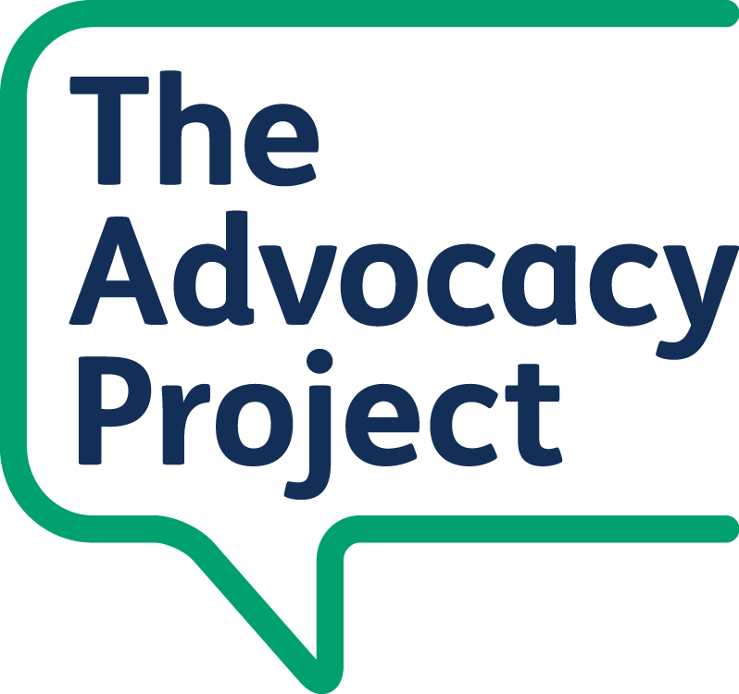

User Council Member - Role Description

Role title | User Council Member.
Organisation | The Advocacy Project.
Number of places | One place is currently available.
Term | 24 months. Members may apply again at the end of their term through the usual selection process.
Time commitment | User Council meetings every 2 to 3 months, plus some preparation or follow-up where agreed. Meetings may last up to 2.5 hours, including a planned break.
Location | Usually in person, unless a reasonable adjustment or different arrangement is agreed. Meetings are usually held at The Stowe Centre (The Advocacy Project Office), or another agreed meeting venue.
Payment | Reward and Recognition payments and reasonable expenses, in line with The Advocacy Project policy.
Application deadline | 12.00pm, Monday 31st August 2026
Contact | Natasha Lobo – natasha@advocacyproject.org.uk

About the User Council
The Advocacy Project (TAP) wants people with lived experience to help shape our work and influence how decisions are made. The User Council is an advisory group that gives people a formal way to share their views, experiences and ideas with The Advocacy Project Board of Trustees.
The User Council helps The Advocacy Project understand what matters to people who use services, carers and people with lived experience. This helps us improve our services, policies, documents and ways of working.
There is already an existing group of User Council Members. We are currently recruiting one new member to join this group.
The Advocacy Project works across several London boroughs, including Camden, Hackney, Westminster, Kensington and Chelsea, Ealing and Brent.

About the role
As a User Council Member, you will use your lived experience to help The Advocacy Project understand what is working well, what could be improved and what people need from advocacy, user involvement and related services.
You may be asked to:
- Share your views, experiences and ideas in User Council meetings.
- Help the User Council give constructive feedback to The Advocacy Project Board of Trustees.
- Review or comment on documents, such as surveys, policies, recruitment materials, leaflets or feedback reports.
- Help identify what could be improved, based on lived experience.
- Advise on accessibility and inclusion, for example for events, recruitment, digital materials or information for service users.
- Work with other User Council Members respectfully, including people whose experiences or views may be different from your own.

Who we are looking for
We welcome applications from people with lived experience of mental health services, learning disability services, social care services, older people’s services or advocacy. This could be your own experience, or experience as a parent or carer.
We will first invite expressions of interest from current or former users of The Advocacy Project services and projects. If we do not receive enough interest, we may open the opportunity more widely to people with relevant lived experience or carer experience.
You don't need to have previous experience of being on a user involvement group, committee or Board to apply. We are interested in people who can listen to others, share views in a helpful way, and think about how services could work better.
We want the User Council to reflect the communities The Advocacy Project works with. We welcome applications from people with different backgrounds and experiences, including disabled people, people with long-term conditions, neurodivergent people, people from different ethnic, cultural and faith backgrounds, people of different ages and genders, LGBT+ people, carers, parents and people from different socio-economic backgrounds.

What we can offer
- Support and information to help you carry out the role.
- A clear contact person at The Advocacy Project.
- Reasonable adjustments where needed.
- We can talk with you about reasonable adjustments before you apply, during the application process, or once you are part of the User Council.
- Experience that may help with future volunteering, involvement or employment opportunities.
- References for future opportunities, where appropriate.
- Reward and Recognition payments and reasonable expenses, in line with The Advocacy Project policy.

Time commitment
We expect the role to involve:
- One User Council meeting every 2 to 3 months.
- Meetings are usually held at The Stowe Centre (The Advocacy Project office), so members will need to travel there for meetings.
- Meetings that are usually in person, unless a reasonable adjustment or different arrangement is agreed.
- We understand that members may need to miss a meeting sometimes. Members should let the facilitator know as soon as possible if they cannot attend or need support to take part.
- Reading or reviewing information before some meetings.
- Occasional feedback or comments between meetings, for example by email, phone or another agreed method.
- Optional extra involvement opportunities, where these are agreed in advance.
Members should tell the facilitator as soon as possible if they can't attend a meeting or need support to take part.

Reward and Recognition and expenses
Reward and Recognition payments are for your involvement as a person with lived experience. This is not an employment relationship with The Advocacy Project.
R&R may be paid in vouchers or by BACS into a bank account. Please be aware that R&R payments may affect your personal financial situation, including benefits. If you need help to understand this, we can signpost you to advice.
The Advocacy Project will process Reward and Recognition (R&R) payments for agreed User Council meetings and activities. Members do not need to make a separate application for R&R payments, but will need to provide bank details or voucher preferences.
Reward and Recognition payments will be calculated using the current London Living Wage hourly rate. The current London Living Wage rate is £14.80 per hour for 2025/2026. If payment is made by voucher, the amount will be rounded to the nearest £5, as vouchers are issued in £5 amounts.
Reasonable travel and other agreed expenses will be paid in line with The Advocacy Project policy.
Travel is usually to The Stowe Centre or another agreed meeting venue. The Advocacy Project will explain how expenses are processed and what receipts or information are needed.

Eligibility
This opportunity is open to people who:
- Are aged 18 or over.
- Are a current or former user of The Advocacy Project services, or have relevant lived experience or carer experience.
- Have lived experience or carer experience of mental health services, learning disability services, social care services, older people's services or advocacy.
- Can commit to attending User Council meetings and taking part respectfully.
- Can usually attend meetings in person at The Stowe Centre, unless a reasonable adjustment or different arrangement is agreed,
There is currently one place available.
Not everyone who applies will be offered a place. We will use a fair selection process based on this role description and the needs of the User Council.

Things to consider before applying
- The role can be rewarding, but it may also involve discussing topics that feel personal or difficult.
- You won't be expected to share anything you don't want to share.
- If you currently use The Advocacy Project services, we can talk with you confidentially about any boundaries, conflicts of interest or support needs before you decide whether to apply.
- User Council Members are asked to think about the views of other service users and carers, as well as their own views and experiences.
- Members must keep confidential information private, unless there is a safety, safeguarding or legal reason to share it.

Person specification

Personal experience
- Lived experience or carer experience relevant to The Advocacy Project's work.
- Interest in improving services and making sure lived experience is heard.
- Awareness that people have different experiences, needs and barriers.

Skills and approach
- Ability to share views and feedback in a constructive way.
- Ability to listen to others and respect different views.
- Ability to think about the experiences of other people, not only your own experience.
- Willingness to look at documents or information before meetings, with support if needed.
- Ability to work cooperatively with other User Council Members and The Advocacy Project staff.
- Ability to communicate with staff by email, phone, post or another agreed method.

Commitment
- Commitment to a 24-month term, where possible.
- Regular attendance at User Council meetings.
- Letting the facilitator know if you can't attend or need support.
- Following the User Council group agreement and The Advocacy Project policies.
- Respecting confidentiality and safeguarding responsibilities.

You don't need to have
- Previous experience of being on a committee, Board or involvement group.
- Formal qualifications.
- Experience of public speaking.

How to apply
There is one place available on the User Council.
To apply, please send us a short email or letter, or contact us by phone, telling us why you’d like to join. You can also send a voice note if that is easier for you.
You don’t need to write a lot. We just want to understand why you’re interested and what you would bring to the User Council. As a guide, you could write up to 300 words, or send a short voice note of around 2 to 3 minutes.
Please tell us:
- Why you’re interested in joining the User Council.
- What lived experience you would bring to the group.
- What you think helps people feel listened to and included.
- Any experience you have of sharing your views, listening to others, or helping improve services.
- Any support or reasonable adjustments you would need to take part.
You can use the role description to help you think about what to write.
If writing is difficult, please contact us. We can talk through another way for you to express your interest, including by phone or voice note.
- Application deadline: 12.00pm, Monday 31st August
- Contact person: Natasha
- Email: natasha@advocacyproject.org.uk
- Phone: 07976 390 897
We can provide the recruitment information in Easy Read or another accessible format. Please contact us if you need this. We will also prepare a shorter Easy Read / accessible version of the role description, advert and application information.

Process
After the closing date, we will read what people have sent us. We may invite some people for an informal conversation. We will explain the process clearly and let everyone know the outcome.

